XXX Annual Meeting
Danish Society for Neuroscience (DSfN)

“The principles of learning in nature, machines and disease”

May 17 – 18; 2016

Hotel Hesselet, Nyborg

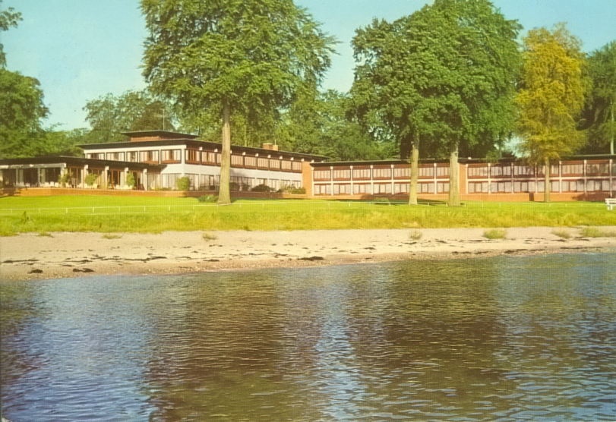

Symposium organizers
Niels Plath, H. Lundbeck A/S
Duda Kvitsiani, University of Aarhus

Location
Hotel Hesselet, Christianslundsvej 119, 5800 Nyborg, Denmark
Phone +45 65313029

Registration and payment
Early registration (before March 15)
Members of DSfN: DKK 3200
Non-members: DKK 4000
Students: DKK 1200

Danish Society for Neuroscience (DSfN)
Annual meeting, May 17-18, 2016
Hotel Hesselet, Nyborg, DK

”The principles of learning in nature, machines and disease”

Tuesday May 17th

09.00 – Arrival, coffee and registration

10.00 - Welcome

10.10 - Introductory lecture: Speaker pending.
Biological learning and machine learning: Commonalities, inspiration and differences.

Session 1: Computational models of learning, machine learning – in theory and applied
Chair: Niels Plath, H. Lundbeck A/S

11.00 – Paolo Marcatili, Technical University of Denmark, DK.
Machine learning in computational biology: common problems and solutions

11.35 – Ole Winther, Technical University of Denmark, DK.
Data science, AI and deep learning

12.10 - Lunch

13.00 – Michael Brammer, King´s College London, UK.
Prediction and classification of mental illness using machine learning

13.35 - Short break

Session 2: Natural models of Learning: Molecular pathways
Chair: Poul Henning Jensen, University of Aarhus, DK

13.45 – Sadegh Nabavi, Dandrite, Aarhus University, DK.
Synaptic tagging and capture: from synapses to behavior

14.20 – Simon Glerup, Dept. Biomedicine, Aarhus University, DK.
Sortilins and sorting out what to remember

14.55 – Clive Bramham, University of Bergen, Norway
The Arc of synaptic memory

15.30 - Coffee and cake, posters

16.00 – Marie Carlen, Karolinska Institute, Sweden
Prefrontal parvalbumin neurons in control of attention

16.40 – DataBlitz 5x10 min (selected abstracts)
Organizer: Trevor Owens, University of Southern Denmark, DK

17.30 - Break

18.30 – Drinks and Dinner

Wednesday May 18th

07.30 - Breakfast

Session 3: Natural models of Learning: Neural circuits
Chair: Albert Gjedde, Univ. of Copenhagen, DK

08.30 – Armin Lak, University Cambridge, UK.
Dopamine learning signals: from perception to economic decisions

09.05 – Jesper Mogensen, University of Copenhagen, DK
Learning in the intact and injured brain: Neurocognitive organization and reorganization

09.40 – Ron Kupers, University of Copenhagen, DK
Learning in the Visually-Deprived Brain: Insights From Darkness

10.15 - Coffee

10:30 – Albert Gjedde, University of Copenhagen, DK
Learning by doing: Neuroimaging of sensation seeking

Session 4: Learning deficits linked to disease
Chair: Niels Plath, H. Lundbeck A/S, DK

11.10 – Barbara Sahakian, University Cambridge, UK.
Title pending

12.00 – Lunch

13.00 – Andreas Heinz, Charite Berlin, DE
Learning mechanisms in affective, addictive and psychotic disorders

13.45 – Steen Hasselbalch, University of Copenhagen, DK
Memory problems in Mild Cognitive Impairment and Alzheimer’s dementia

14.30 - Short break

14.45 – Closing lecture: Surjo Soekadar, Univeristy of Tübingen, DE
Outlook and integration
Brain machine interfaces (BMI) as an example of fusing machine learning with biological learning.

15.45 – Concluding remarks and Departure

Registration Form

Danish Society for Neuroscience (DSfN)
Annual meeting, May 17-18 2016 Hotel Hesselet, Nyborg, DK

Please send to Lisbeth Causse: lcausse@nexs.ku.dk

Title + Name:

Institution: Country:

Email address:

Registration fee: Early registration Late registration
Before March 15th Latest April 24th

Member of DSfN kr. 3200 Kr. 4000

Member of DSfN and student kr. 1200 Kr. 1500
(max 20 students at reduced rate)

Non-member kr. 4000 Kr. 4500

Accompanying person kr. 4000 Kr. 4500

Name of accompanying person: _____________________________________________

The registration fee covers catering during the meeting and one night of accommodation from May 17th – 18th.

Please check of the appropriate boxes:
Accommodation: May 16-17 May 17-18 May 18-19

Payment:
The amount DKK___________________ has been transferred to Danske Bank
Registration No: 1551, account 0010639212. Please indicate your name!

Send EAN- Invoice to: EAN number:
Attn. Name:
Institute and address:
Cancellation:
As long as the Society can be reimbursed from the hotel, participants can be reimbursed after deduction of a handling fee of 500 DKK.

Questions: Please contact secretary Lisbeth Rosenberg Causse, +45 35327314 or program chair Niels Plath (niep@lundbeck com)
Please send the registration form to: lcausse@nexs.ku.dk

